**| Cultural evolution of social complexity in ancient civilisations across the globe |**

1. Introduction/background

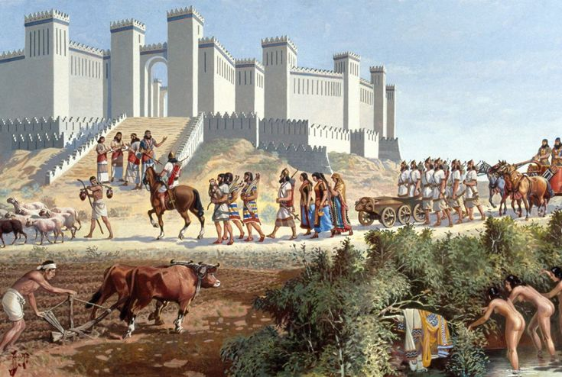The transition from small-scale human groups to complex, multilevel, and hierarchically structured human societies has long been a scientific puzzle. Major transitions in complexity over evolutionary time are of extraordinary interest to scholars from widely different fields such as archaeology, anthropology, biology, psychology, sociology, and philosophy. Therefore, it is of utmost scientific relevance to better understand what drives the change of social complexity in human societies worldwide and to what extent there are generalisable processes and patterns in the evolution of human societies (1). When we investigate the complexity of human civilisations, this where biological evolution and cultural evolution meet, and exciting endeavour makes a large-scale interdisciplinary collaboration necessary. The data set used for this project is about social complexity in various ancient human societies across the globe, and we are going to explore how social complexity changed over time in those societies.

Figure 1 | Image of an ancient civilisation.

1. Map

   Description automatically generatedMethods

Figure 2 | Global map of the NGAs in the social complexity data set. Figure taken from Turchin et al 2017.

For this project, I used a data set available from *SESHAT – The Global History Databank*, a large databank collecting archaeological and anthropological data (2,3). This database is meant to advance our understanding of how modern human societies evolved from their ancient predecessors. I created my script containing annotated and commented code for the data exploration and analysis using a notebook in the *Jupyter Lab* interface (version 2.1.5) for *Python*. For this project I focused on a descriptive visualisation of the data instead of conducting in-depth inferential analyses.

1. Results

Figure 3 | Change in social complexity (SPC1) over time in four ancient societies of Europe and three ancient societies in Africa.

Social complexity values changed over time and increased for most NGAs (Natural Geographic Areas) (Figure 2,3). There was no clear difference in terms of the development of social complexity between NGAs from different continents. Older societies seemed to reach higher values of social complexity overall. The highest values that NGAs reached in their evolution differed quite remarkably, with nine NGAs reaching values of over 0.9 and nine NGAs staying below 0.4 (Figure 4).

Figure 4 | Highest social complexity (SPC1) values for different NGAs across the globe.

1. Summary and conclusion

We have seen that ancient civilisations across the globe differed quite remarkably in social complexity, and many societies underwent a marked increase in social complexity over time. Some of the variables characterising social complexity were highly positively correlated, and therefore it is sensible to use SPC1 as a proxy for social complexity. This also suggest that several measures of the complexity of human societies might be closely linked and evolve dependently on each other. More inferential and quantitative research is needed to draw solid conclusions.

1. References

1. Turchin P, Currie TE, Whitehouse H, François P, Feeney K, Mullins D, et al. Quantitative historical analysis uncovers a single dimension of complexity that structures global variation in human social organization. Proc Natl Acad Sci U S A. 2017;115(2):E144–51.

2. Turchin P, Brennan R, Currie TE, Feeney KC, François P, Hoyer D, et al. Seshat: The Global History Databank. Cliodynamics. 2015;6(1):77–107.

3. Whitehouse H, François P, Turchin P. The role of ritual in the evolution of social complexity: Five predictions and a drum roll. Cliodynamics. 2015;6(2):199–210.

This research employed data from the Seshat Databank ([seshatdatabank.info](http://seshatdatabank.info/)) under [Creative Commons Attribution Non-Commercial (CC By-NC SA)](https://creativecommons.org/licenses/by-nc-sa/4.0/legalcode) licensing. Some of the data visualisation and analyses where inspired by a data exploration by Muskan Jain on Kaggle.

Links: (1) Personal *GitHub -* <https://github.com/lucaqu/social-complexity-ancient-civilisation> (2) *SESHAT* -<http://seshatdatabank.info/> (3) Social complexity data set on *Kaggle* - <https://www.kaggle.com/datasets/usharengaraju/social-complexity-dataset-ancient-civilization> (4) Evolution of social complexity: a data analysis -<https://www.kaggle.com/code/muskan2006/evolution-of-social-complexity-a-data-analysis>